Practice-It and Graphs

Go to the Practice-It website at: <http://practiceit.cs.washington.edu/>

After you log in, click on **Start Practicing!**

Select **University of Washington CSE 373**

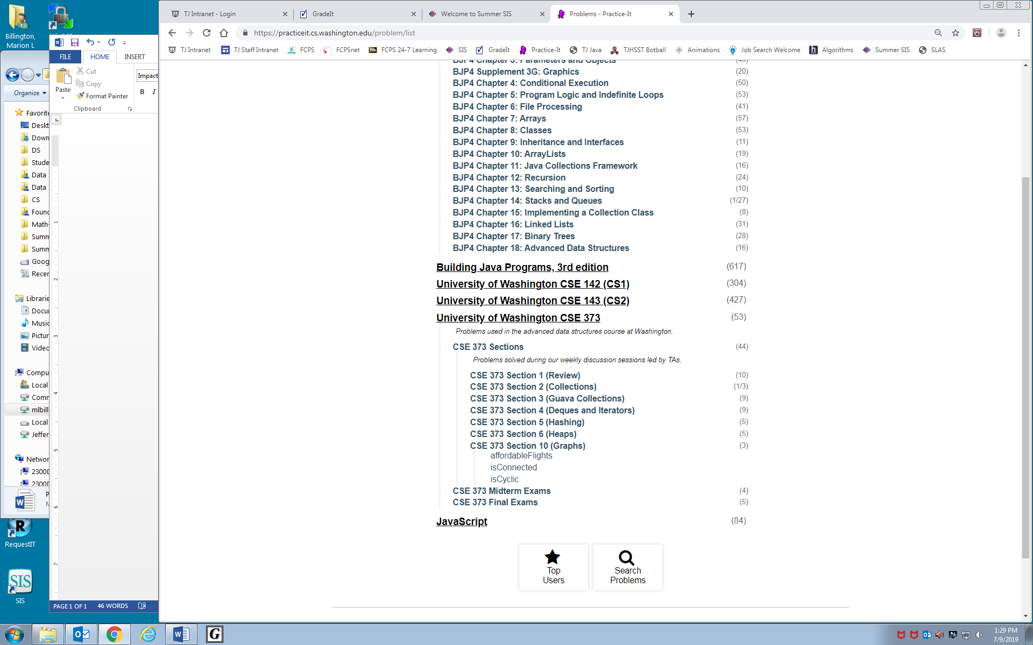Select **CSE 373 Sections**

Select **CSE 373 Section 10 (Graphs)**

Your assignment is to solve all 3 problems.